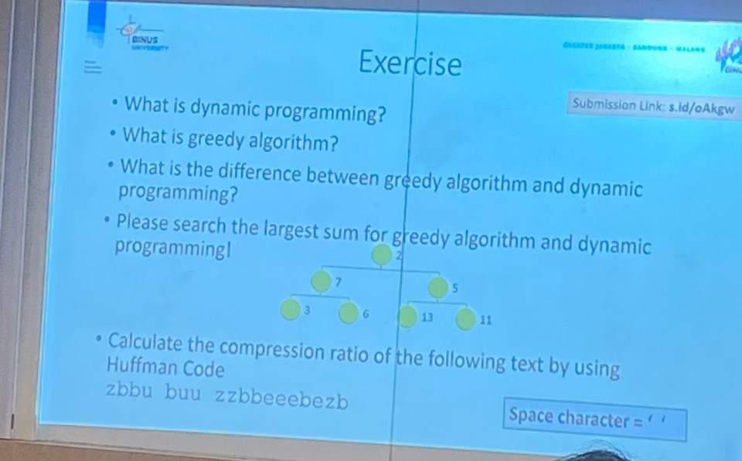

1. **What is dynamic programming?**

Dynamic programming is a problem-solving algorithm technique where the problem is broken down to smaller subproblems and solving each of those subproblems only once, there are two techniques which memoization (top down) and tabulation (bottom up)

1. **What is a greedy algorithm?**

Greedy algorithm is a class of algorithms which solves a problem step by step in a top-down approach by choosing the best option at the moment to create a globally optimum choice.

1. **What is the difference between greedy algorithms and dynamic programming?**

Greedy algorithms only take the best solutions in a smaller scale in hopes that it would lead to a globally optimum choice while dynamic programming finds the best solution for the overall problem.

1. **Please search the largest sum for greedy algorithms and dynamic programming!**Greedy algorithm: 2 -> 7 -> 6 = 15

Dynamic programming: 2 -> 5 -> 13 = 20

1. **Calculate the compression ratio of the following text using Huffman Coding**

Frequency:

z = 4

b = 7

u = 3

e = 4

‘ ‘ = 2

Huffman Tree

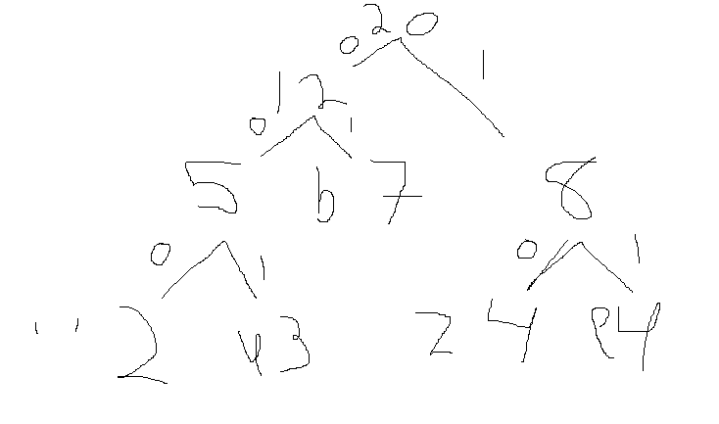

| Character | Frequency | Code |
| --- | --- | --- |
| ‘ ‘ | 2 | 000 |
| u | 3 | 001 |
| b | 7 | 01 |
| z | 4 | 10 |
| e | 4 | 11 |

Original Bit Length: 2 + 3 + 7 + 4 + 4 = 20

Using ASCII = 20 x 8 = 160 bits

Compressed Bit Length:

‘ ‘ = 2 x 3 = 6

u = 3 x 3 = 9

b = 7 x 2 = 14

z = 4 x 2 = 8

e = 4 x 2 = 8

Total = 45 bits

160/45 = 3.555